SS Freshspring

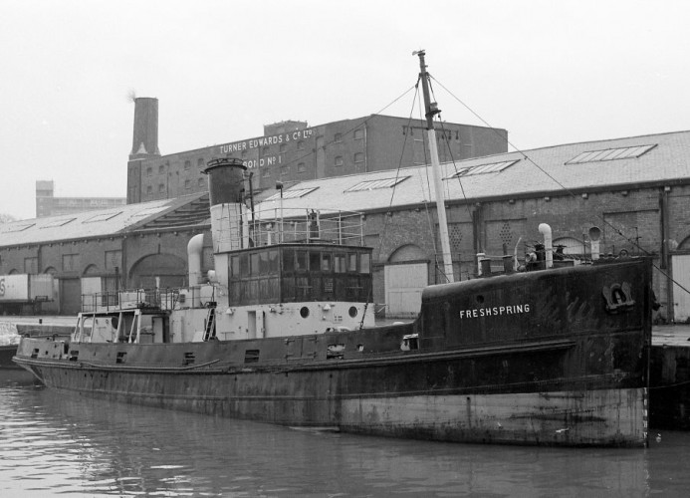
History

SS Freshspring is a steam ship. She was built in 1946 for the Royal Navy.

The ship was first launched on the 15th August 1946 and by February 1947, she was sailing her way to Malta. This was where the ship would be based for 20 years!

Historic SS Freshspring



In 1967, SS Freshspring returned to England. This was because another, similar ship (called Freshpond) needed replacing.

In 1979, SS Freshspring was put up for sale by the Royal Navy and was bought by a man called Oswald Burgess, who moved the ship to Bristol.

Malta. This is where SS Freshpring was based with the Navy for around 20 years!

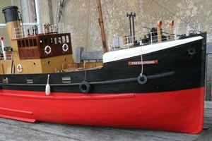

In 2013, The Steamship Freshspring Trust was formed. They did lots of work on the ship to restore it. In October 2016, the society towed SS Freshspring to Bideford. This is where the ship is today!

SS Freshspring being restored.

What are steamships?

A steam ship is a boat which is powered by steam engines.

One or more boilers on board the ship heat water to a high temperature – this creates steam! The steam can then be used to power the steam engine. The steam engine makes the boat move!

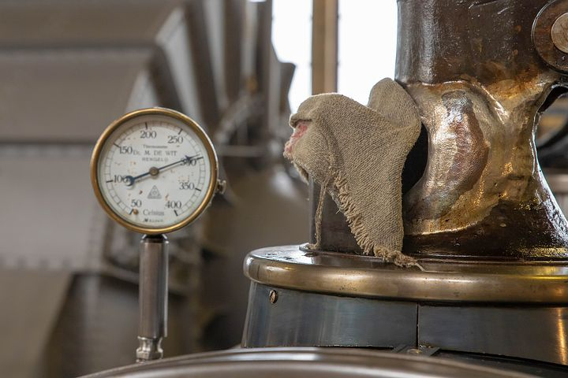

A boiler. SS Freshspring used a boiler to heat water and create steam. It was the steam that powered the ship’s engine!

SS Freshspring today

Over the past few years, lots of work has gone into restoring SS Freshspring. With the help of lots of volunteers, the ship is being transformed!

Every year, SS Freshspring welcomes visitors on board in Bideford, to explore the ship and find out more about her history.

An important part of the Freshpring Trust’s work is helping children to learn all about the ship, how it worked and to encourage them to consider a career at sea! Over the years, the trust has done lots of work with children in schools and on board the ship too!
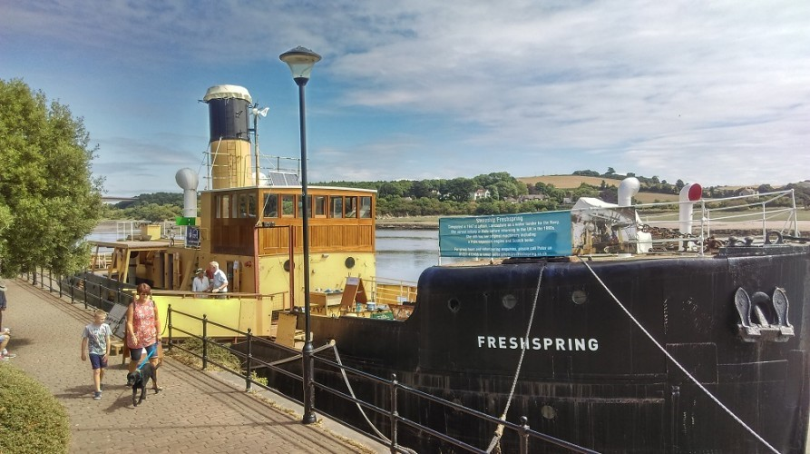
SS Freshspring docked in Bideford.

